What is IPv4 and IPv6?

IP4 and IP6 refer to two versions of the Internet Protocol (IP), which is a set of rules governing how data is sent and received over the internet.

IPv4 (Internet Protocol version 4):

It is the fourth version of the IP and the most widely used.
Uses a 32-bit address format.
Allows for about 4.3 billion unique IP addresses.
Addresses are written in decimal as four numbers separated by periods (e.g., 192.168.1.1).

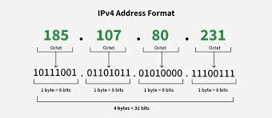

Due to the limited number of addresses, IPv4 address exhaustion has become a concern.

IPv6 (Internet Protocol version 6):

It is the successor to IPv4, designed to address IPv4 limitations.
Uses a 128-bit address format.
Allows for a vastly larger number of unique IP addresses (approximately 3.4 x 10^38).

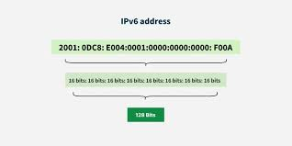

Addresses are written in hexadecimal and separated by colons (e.g., 2001:0db8:85a3:0000:0000:8a2e:0370:7334).
Includes improvements like simplified address assignment and enhanced security features.

What is a Subnet?

A subnet (short for subnetwork) is a segmented piece of a larger network. It is used to divide a bigger network into smaller, more manageable parts.

Key Points about Subnets:

Purpose: Subnets help improve network performance and security by organizing and isolating groups of devices within a larger network.

How it works: A subnet divides an IP network into multiple smaller networks by using a subnet mask that separates the IP address into the network and host portions.
Subnet Mask: This is a number that defines which part of an IP address refers to the network and which part refers to the device (host).
Example: In IPv4, an IP address like 192.168.1.0 with a subnet mask of 255.255.255.0 means the first three parts (192.168.1) identify the network, and the last part identifies individual devices within that subnet.

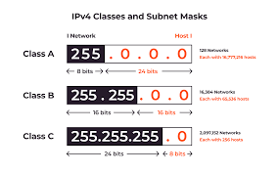

Benefits:
Reduces network congestion by limiting broadcast traffic to within subnets.
Enhances security by isolating groups of devices.
Makes network management easier.

What is Network Address Translation (NAT)?

Network Address Translation (NAT) is a networking technique used to modify the IP address information in data packets as they pass between different networks, typically between a private local network and the public internet.

Key Points about NAT:

Purpose: NAT allows multiple devices on a private network to share a single public IP address when accessing the internet.

How it works: When a device inside a private network sends data to the internet, NAT translates the private IP address of that device to the public IP address of the router or gateway. When the response comes back, NAT translates the public IP address back to the appropriate private IP address.

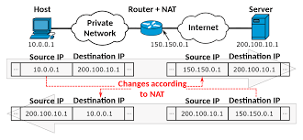
Benefits:
Conserves the limited number of public IP addresses.
Provides an additional layer of security by hiding internal IP addresses from external networks.

Types of NAT:

Static NAT: Maps one private IP address to one public IP address.

Dynamic NAT: Maps a private IP address to any available public IP address from a pool.

PAT (Port Address Translation) or NAT Overloading: Maps multiple private IP addresses to a single public IP address by using different port numbers.

